P250/2
GEOGRAPHY
(WORLD PROBLEMS & DEVELOPMENT)
PAPER 2
2023
3HOURS

Uganda Advanced Certificate of Education
GEOGRAPHY
(World Problems & Development)
PAPER 2
3HOURS

INSTRUCTIONS TO CANDIDATES

- Answer four questions in all
- Section A is compulsory
- Answer three questions from section B
- Any additional question(s) attempted will not be marked
- Credit will be given for use of relevant sketch maps, diagrams and specific examples.

SECTION A:
- Study the table provided below showing land area and population size for selected African countries and answer questions that follow.

COUNTRY | LAND AREA (000’km²) | POPULATION SIZE (‘000s)
Algeria  Central African Rep.  Chad  Djibouti  Egypt  Ethiopia  Libya  Morocco  Niger  Somalia  Sudan  Tunisia | 2,382  623  1,259  23  995  1,000  1,760  446  1,267  627  2,376  155 | 30,800  3,800  7,900  600  65,200  65,800  5,400  29,200  11,200  9,100  31,700  9,700

Adopted: 2003 African Development inductors; World Bank, Washington D.C Pg.5
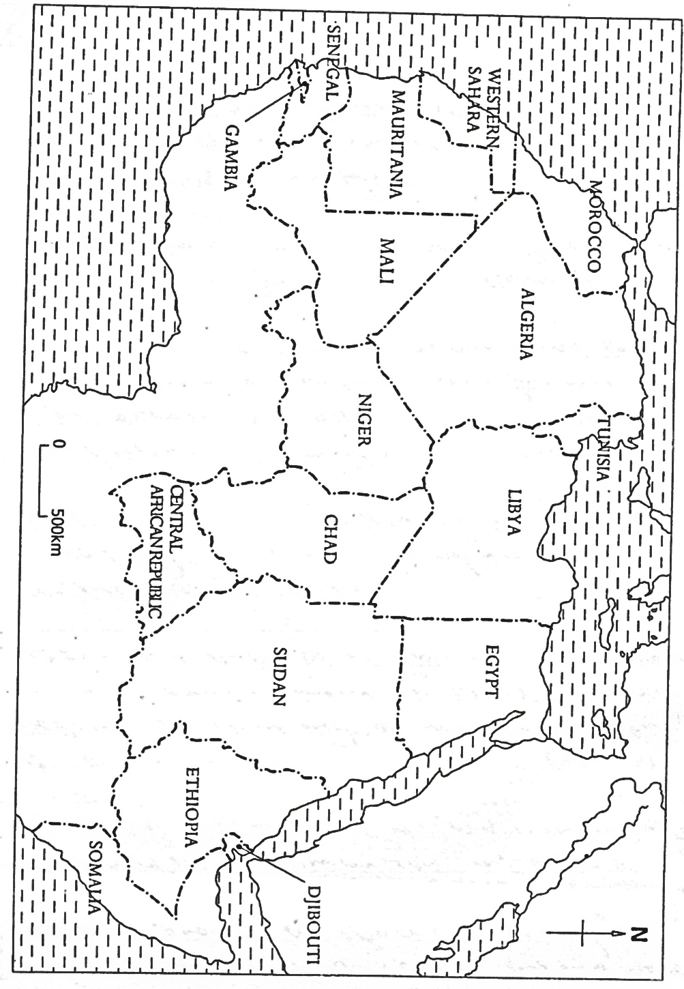
- Calculate the population density for each of the selected countries shown in the table 06mks
- Using the base map provided, draw achoropleth (density) map to represent the information obtained in (a) above

- Outline the merits and demerits of the statistical method used in (b) above
- Explain the causes of the variations in the population density of the region shown on the base map.

SECTION B:

- Assess the contribution of co-operative farming to the development of either Kenya or Denmark
- (a) Distinguish between bureau forests and tropical rain forests 10mks
(b) Explain the factors which have favoured the growth of tropical rain forests in either Brazil or the Democratic republic of Congo 15mks
- Assess the contribution of fishing industry to the development of either China or Peru 25mks
- Assess the impact of the mining industry on the environment in either the Ruhr region of Germany or the Rand region of South Africa 25mks
- To what extent has altitude influenced population distribution in Africa 25mks
- With reference to specific examples, explain the importance of inland water transport in either United States of America or Western Europe 25mks
- Explain the problems faced by the tourist industry in either Kenya or Egypt 25mks

END.

